Day 3

Tic tac toe problem

import os

import time

board = [' ',' ',' ',' ',' ',' ',' ',' ',' ',' ']

player = 1

########win Flags##########

Win = 1

Draw = -1

Running = 0

Stop = 1

###########################

Game = Running

Mark = 'X'

#This Function Draws Game Board

def DrawBoard():

print(" %c | %c | %c " % (board[1],board[2],board[3]))

print("___|___|___")

print(" %c | %c | %c " % (board[4],board[5],board[6]))

print("___|___|___")

print(" %c | %c | %c " % (board[7],board[8],board[9]))

print(" | | ")

#This Function Checks position is empty or not

def CheckPosition(x):

if(board[x] == ' '):

return True

else:

return False

#This Function Checks player has won or not

def CheckWin():

global Game

#Horizontal winning condition

if(board[1] == board[2] and board[2] == board[3] and board[1] != ' '):

Game = Win

elif(board[4] == board[5] and board[5] == board[6] and board[4] != ' '):

Game = Win

elif(board[7] == board[8] and board[8] == board[9] and board[7] != ' '):

Game = Win

#Vertical Winning Condition

elif(board[1] == board[4] and board[4] == board[7] and board[1] != ' '):

Game = Win

elif(board[2] == board[5] and board[5] == board[8] and board[2] != ' '):

Game = Win

elif(board[3] == board[6] and board[6] == board[9] and board[3] != ' '):

Game=Win

#Diagonal Winning Condition

elif(board[1] == board[5] and board[5] == board[9] and board[5] != ' '):

Game = Win

elif(board[3] == board[5] and board[5] == board[7] and board[5] != ' '):

Game=Win

#Match Tie or Draw Condition

elif(board[1]!=' ' and board[2]!=' ' and board[3]!=' ' and board[4]!=' ' and board[5]!=' ' and board[6]!=' ' and board[7]!=' ' and board[8]!=' ' and board[9]!=' '):

Game=Draw

else:

Game=Running

print("Tic-Tac-Toe Game Designed By Sourabh Somani")

print("Player 1 [X] --- Player 2 [O]\n")

print()

print()

print("Please Wait...")

time.sleep(3)

while(Game == Running):

os.system('cls')

DrawBoard()

if(player % 2 != 0):

print("Player 1's chance")

Mark = 'X'

else:

print("Player 2's chance")

Mark = 'O'

choice = int(input("Enter the position between [1-9] where you want to mark : "))

if(CheckPosition(choice)):

board[choice] = Mark

player+=1

CheckWin()

os.system('cls')

DrawBoard()

if(Game==Draw):

print("Game Draw")

elif(Game==Win):

player-=1

if(player%2!=0):

print("Player 1 Won")

else:

print("Player 2 Won")

output:

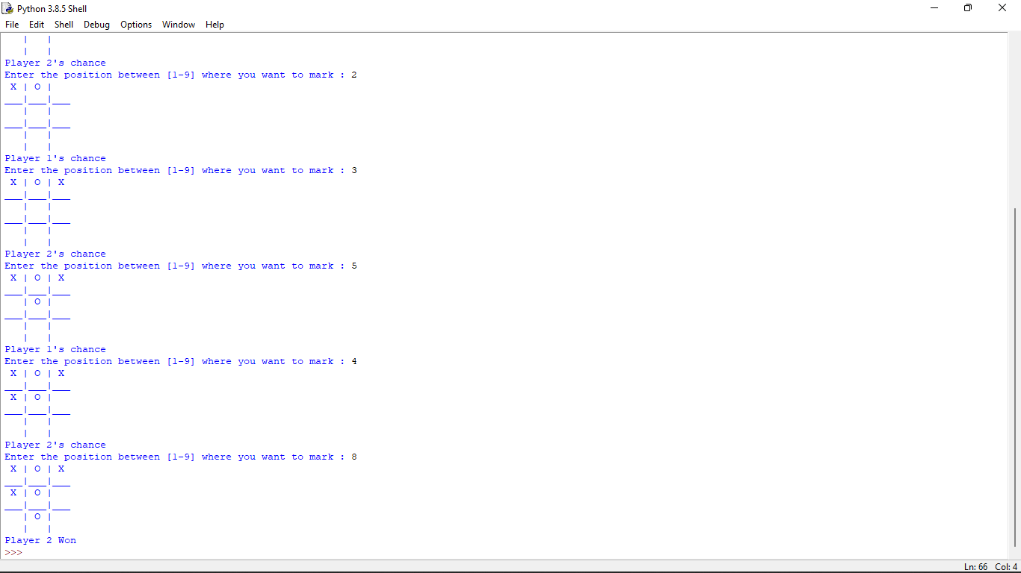

Min max problem

import math

def minimax (curDepth, nodeIndex,

maxTurn, scores,

targetDepth):

if (curDepth == targetDepth):

return scores[nodeIndex]

if (maxTurn):

return max(minimax(curDepth + 1, nodeIndex * 2,

False, scores, targetDepth),

minimax(curDepth + 1, nodeIndex * 2 + 1,

False, scores, targetDepth))

else:

return min(minimax(curDepth + 1, nodeIndex * 2,

True, scores, targetDepth),

minimax(curDepth + 1, nodeIndex * 2 + 1,

True, scores, targetDepth))

scores = [3, 5, 2, 9, 12, 5, 23, 23]

treeDepth = math.log(len(scores), 2)

print("The optimal value is : ", end = "")

print(minimax(0, 0, True, scores, treeDepth))

output:

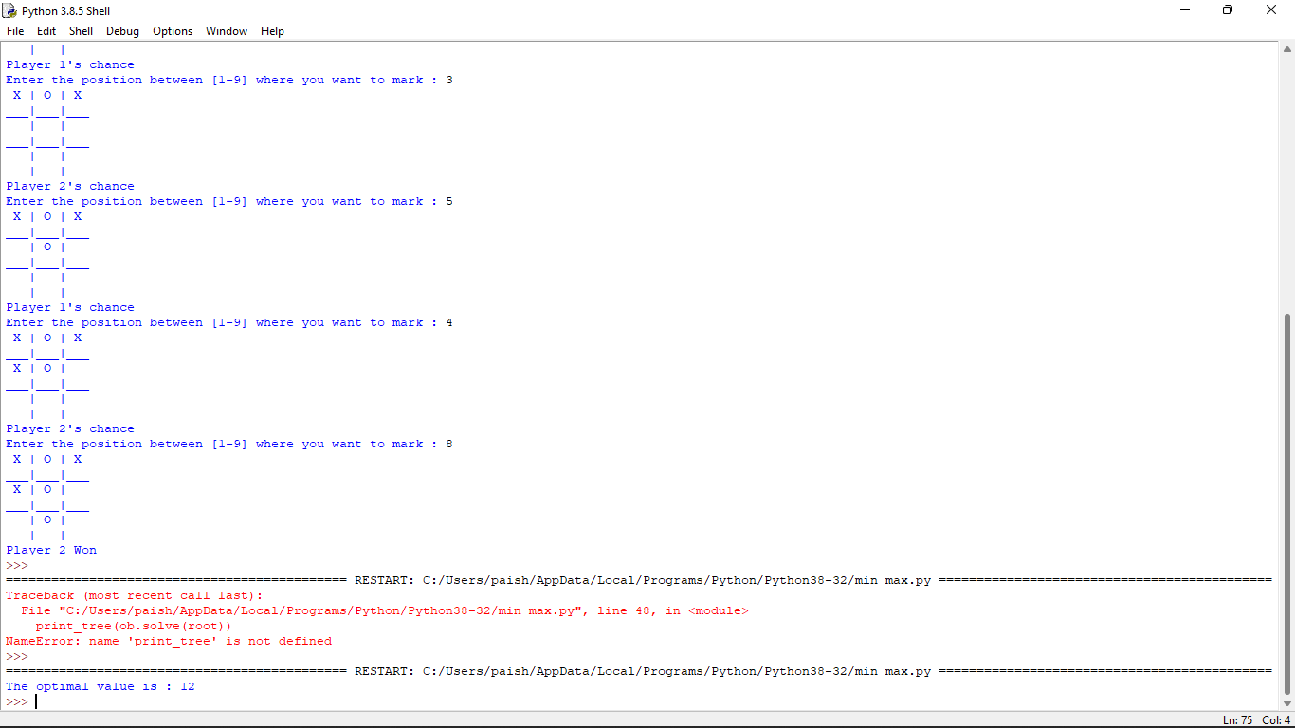

Alpha-beta pruning:

MAX, MIN = 1000, -1000

def minimax(depth, nodeIndex, maximizingPlayer,values, alpha, beta):

if depth == 3:

return values[nodeIndex]

if maximizingPlayer:

best = MIN

for i in range(0, 2):

val = minimax(depth + 1, nodeIndex * 2 + i,False, values, alpha, beta)

best = max(best, val)

alpha = max(alpha, best)

if beta <= alpha:

break

return best

else:

best = MAX

for i in range(0, 2):

val = minimax(depth + 1, nodeIndex * 2 + i,

True, values, alpha, beta)

best = min(best, val)

beta = min(beta, best)

if beta <= alpha:

break

return best

if __name__ == "__main__":

values = [3, 5, 6, 9, 1, 2, 0, -1]

print("The optimal value is :", minimax(0, 0, True, values, MIN, MAX))

output:

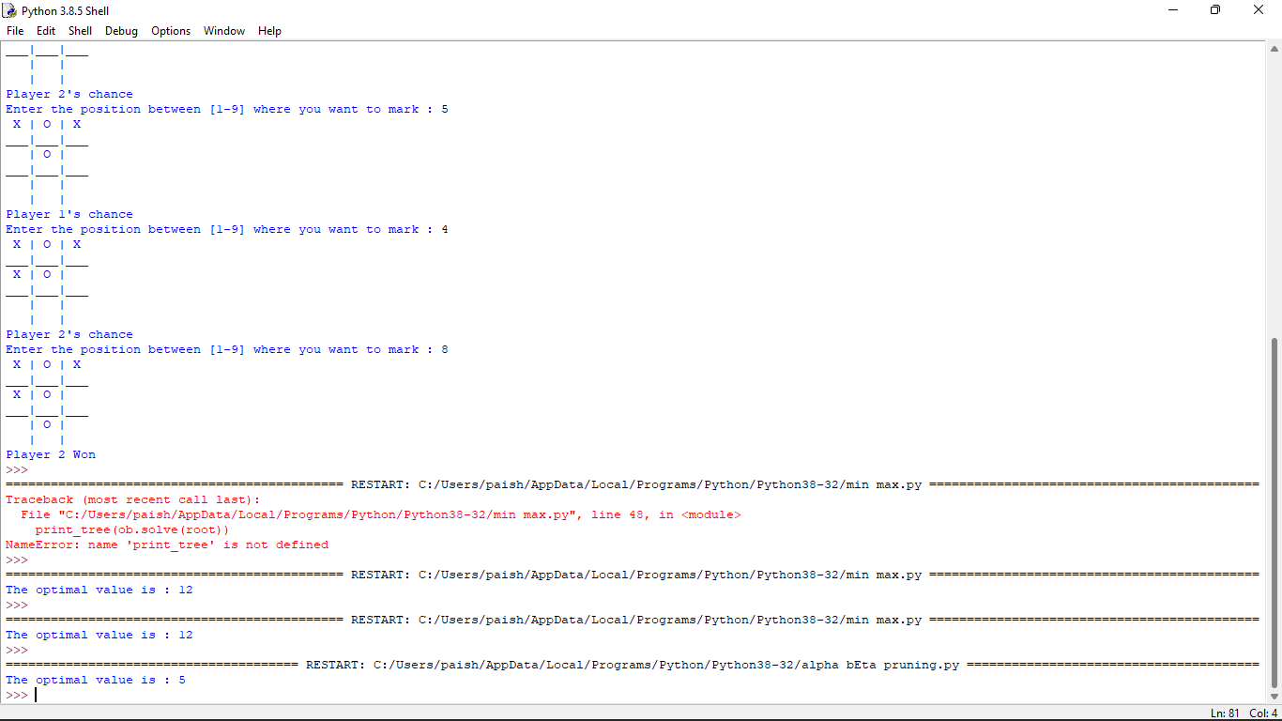

Decision tree

# Run this program on your local python

# interpreter, provided you have installed

# the required libraries.

# Importing the required packages

import numpy as np

import pandas as pd

from sklearn.metrics import confusion_matrix

from sklearn.model_selection import train_test_split

from sklearn.tree import DecisionTreeClassifier

from sklearn.metrics import accuracy_score

from sklearn.metrics import classification_report

# Function importing Dataset

def importdata():

balance_data = pd.read_csv(

'https://archive.ics.uci.edu/ml/machine-learning-'+

'databases/balance-scale/balance-scale.data',

sep= ',', header = None)

# Printing the dataswet shape

print ("Dataset Length: ", len(balance_data))

print ("Dataset Shape: ", balance_data.shape)

# Printing the dataset obseravtions

print ("Dataset: ",balance_data.head())

return balance_data

# Function to split the dataset

def splitdataset(balance_data):

# Separating the target variable

X = balance_data.values[:, 1:5]

Y = balance_data.values[:, 0]

# Splitting the dataset into train and test

X_train, X_test, y_train, y_test = train_test_split(

X, Y, test_size = 0.3, random_state = 100)

return X, Y, X_train, X_test, y_train, y_test

# Function to perform training with giniIndex.

def train_using_gini(X_train, X_test, y_train):

# Creating the classifier object

clf_gini = DecisionTreeClassifier(criterion = "gini",

random_state = 100,max_depth=3, min_samples_leaf=5)

# Performing training

clf_gini.fit(X_train, y_train)

return clf_gini

# Function to perform training with entropy.

def tarin_using_entropy(X_train, X_test, y_train):

# Decision tree with entropy

clf_entropy = DecisionTreeClassifier(

criterion = "entropy", random_state = 100,

max_depth = 3, min_samples_leaf = 5)

# Performing training

clf_entropy.fit(X_train, y_train)

return clf_entropy

# Function to make predictions

def prediction(X_test, clf_object):

# Predicton on test with giniIndex

y_pred = clf_object.predict(X_test)

print("Predicted values:")

print(y_pred)

return y_pred

# Function to calculate accuracy

def cal_accuracy(y_test, y_pred):

print("Confusion Matrix: ",

confusion_matrix(y_test, y_pred))

print ("Accuracy : ",

accuracy_score(y_test,y_pred)*100)

print("Report : ",

classification_report(y_test, y_pred))

# Driver code

def main():

# Building Phase

data = importdata()

X, Y, X_train, X_test, y_train, y_test = splitdataset(data)

clf_gini = train_using_gini(X_train, X_test, y_train)

clf_entropy = tarin_using_entropy(X_train, X_test, y_train)

# Operational Phase

print("Results Using Gini Index:")

# Prediction using gini

y_pred_gini = prediction(X_test, clf_gini)

cal_accuracy(y_test, y_pred_gini)

print("Results Using Entropy:")

# Prediction using entropy

y_pred_entropy = prediction(X_test, clf_entropy)

cal_accuracy(y_test, y_pred_entropy)

# Calling main function

if __name__=="__main__":

main()

output:

